Module 2: Serving the Customer throughout the Policy Lifecycle 1
Lesson 2: New Business and Underwriting 1
Learning Objectives 1
New Business Process 2
Efficiencies in New Business Underwriting 13
Underwriting Overview 19
Field Underwriting and Teleunderwriting 25
Categories of Risk Factors 29
Sources of Information and Underwriting Tools 37

Module 2: Serving the Customer throughout the Policy Lifecycle
A customer's contact with an insurer most likely begins when they are thinking about purchasing a policy, and can last until the policyowner dies and the insurer pays the policy proceeds to the beneficiary. In between, the insurer underwrites and issues the policy, and meets the customer’s service needs while the policy is in force. In this module, you’ll learn about the tasks an insurer performs at each stage of the policy lifecycle.
In this module, you’ll learn about
- How insurers engage with potential customers and distribute products to meet customer needs
- How insurers process insurance applications, evaluate the risk they represent, and determine the appropriate premium to charge
- How insurers try to optimize the experience of their customers
- How insurers balance paying legitimate claims promptly and accurately with avoiding paying illegitimate claims

Lesson 2: New Business and Underwriting
When the insurer receives an application, it needs to evaluate the risk involved in issuing a policy in order to charge a fair price. Learn how insurers obtain the information they need and use it to properly underwrite and issue a policy, and how this once lengthy process is getting shorter.

Learning Objectives

- Describe the primary components of the new business process.
- Explain how insurers use technological advances to increase the efficiency of the new business and underwriting process.
- Describe the underwriting process and the importance of sound underwriting to a company's financial viability.
- Describe the processes of field underwriting and teleunderwriting.
- Identify and explain the three main categories of risk factors that underwriters consider.
- Identify and describe the various sources of information and underwriting tools that underwriters use to assess risk.
- Explain how insurers classify risks and make an underwriting decision.

New Business Process
Learning Objective
Describe the primary components of the new business process.
When an insurance company receives an application for insurance, the company must assess the degree of risk associated with the application. Underwriting is the process of (1) assessing and classifying the degree of risk a proposed insured or group represents and (2) making a decision to accept or decline that risk. An underwriter evaluates risks and makes the underwriting decision.
Deciding which applications to accept is not easy. Financial professionals and underwriters play critical roles in this process. In this lesson, we'll learn how the new business and underwriting areas evaluate the risk presented by proposed insureds and make underwriting decisions.
Underwriting is part of new business processing, but it's not the only part. New business processing for life insurance includes all of the activities involved in
- Processing applications
- Underwriting applications
- Issuing policies
In some companies, such as Forthright, new business and underwriting are part of the same department; in other companies, they're separate departments.
Components of the New Business Process
As we will discuss later in the lesson, many of the following steps can be performed instantly and automatically by an insurer's automated systems. However, each application generally goes through all of the following steps, whether manually or automatically. Here are the common steps of the new business process: the actions taken to turn an application into a policy.
The New Business Process
Data entry
- ID# assigned
- Case file created
Good order check
- Application form is correct one
- Application form and product applied for have state approval
- Application is complete
- Other forms required by insurer and state have been completed
- Financial professional and insurer are licensed to sell policy
Suitability or best interest check
- Double-check that financial professional sold amount and type of coverage that are appropriate for the customer
- Ensure the product meets best interest standards as applicable
Insurer's records searched for information about applicant and insured, such as
- Other coverage
- Other applications pending or denied
- Prior claims or complaint
Underwriting
- Assessing risk
- Classifying risk
- Making underwriting decision
Policy issue
- Enter data
- Assemble policy
- Facilitate policy delivery
- Collect post-issue requirements
Suitability
Determining suitability is an important step because insurance companies want to be sure that applicants are applying for products that best meet their needs.

James Propov is an 83-year-old retiree living solely on Social Security, and he has a net worth of $73,000. He wants to buy a life insurance policy so his adult children can inherit something to compensate them for the care of his five dogs upon his death.
Do you think Mr. Propov would be a suitable candidate for variable life insurance?
- Yes
- No
- Can’t tell; need more information
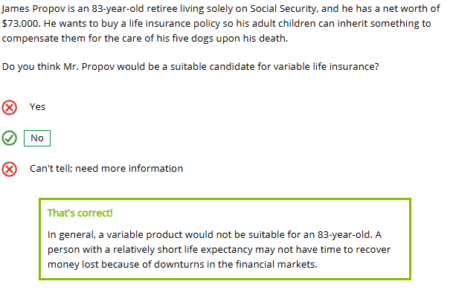
Suitability is particularly important for annuities because many factors can affect whether it's the right product for an applicant. Use the right arrows below to learn about factors to consider.

Age

Does the person have sufficient time to let funds grow?

Income

Does the person have the financial means to buy the annuity?

Liquidity
Does the person have other liquid assets for an emergency? There can be high surrender charges if the owner withdraws funds early.


Risk Tolerance

How comfortable is the person with risk?

Insurance companies have a responsibility to ensure that financial professionals recommend products appropriate, or suitable, for an individual's needs. Both federal law and state laws require insurers to check for suitability in insurance sales. Some state laws require additional suitability checks for products sold to seniors.
Listen to an expert explain how a company can take further steps to prevent abuse of seniors.
Best Interest
In addition to suitability requirements, insurers must comply with any best interest regulations that apply. A best interest standard is a more stringent standard than suitability. The state of New York has enacted New York Regulation 187 that applies a best interest standard to all insurance products issued in the state. Other states are considering enacting similar regulations at the state level. The federal SEC has enacted Regulation Best Interest (Reg BI) that applies a best interest standard to the sale of variable insurance and annuity products.

When Reg BI applies, the financial professional and the financial institution with which the financial professional is affiliated must act in the best interest of a retail customer at the time a sales recommendation is made, without placing the financial or other interests of the financial professional or the financial institution ahead of the interests of the retail customer.
Reg BI imposes four obligations:
- Disclosure. The financial professional must make a full and fair disclosure of all material facts at the time of an investment recommendation. Disclosure includes facts about the recommendation, any conflicts of interest associated with a recommendation, and the scope of the relationship between the retail customer and the financial professional.
- Care. The financial professional must act with reasonable diligence, care, and skill to understand the potential risks, rewards, and costs associated with a recommendation, and to consider those factors in light of the customer's investment profile in making recommendations that are in the customer's best interest, and that do not put the financial professional's interests ahead of the customer's interest. Although costs are expressly required in evaluating recommendations, the financial professional is not required to recommend the lowest cost option.
- Conflict of Interest. The financial institution must establish, maintain, and enforce policies and procedures reasonably designed to mitigate (and in some cases, eliminate) identified conflicts of interest, such as sales contests, that create incentives to make recommendations that are not in the retail customer's best interest.
- Compliance. The financial institution must establish, maintain, and enforce written policies and procedures reasonably designed to achieve compliance with Reg BI.
Insurers generally create procedures that must be followed to ensure suitability or, when applicable, best interest. As part of the new business process, the insurer's new business staff ensure that all the relevant procedures have been followed. If the application is submitted by a financial professional working for an intermediary, the intermediary organization will generally also have procedures in place to ensure suitability or best interest.

Underwriting is the process of (choose all that apply):
- Establishing premium rates to be charged for specific products
- Assessing and classifying the degree of risk a proposed insured or group represents
- Making a decision to accept or decline a proposed risk
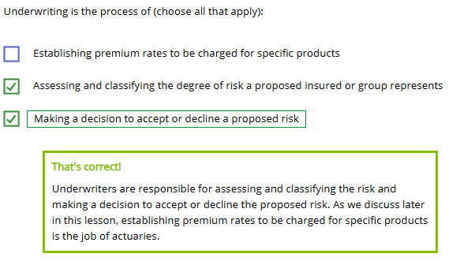
During the good order check, a new business employee or the insurer's automated system ensures that the (choose all that apply):
- Case file is created
- Application form is the correct one
- Forms required by the insurer and state have been completed
- Financial professional and insurer are licensed to sell the policy
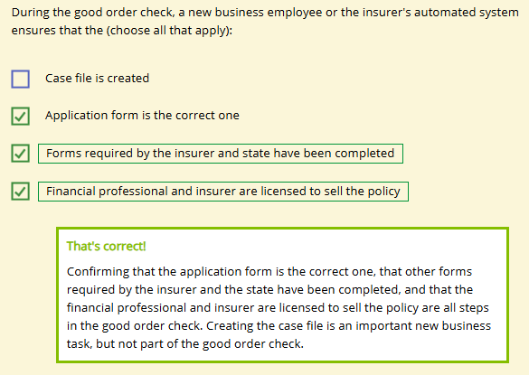
The process of determining whether a particular insurance or annuity product is an appropriate purchase for an applicant based on the applicants needs and financial condition is known as
- New business
- Underwriting
- Checking suitability
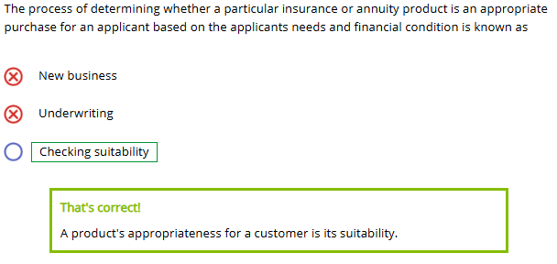
True or False?
In order to comply with Reg BI, insurers and financial professionals recommending variable annuity and insurance products must place the customer's financial interests ahead of the financial professional's or the insurer's interests.
- True
- False
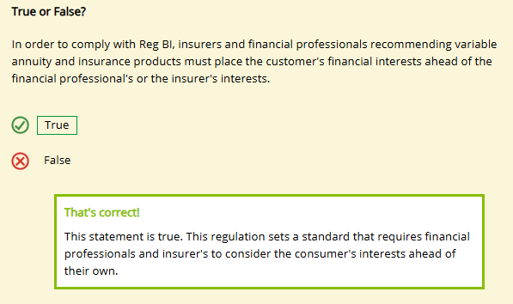

Efficiencies in New Business Underwriting
Learning Objective
Explain how insurers use technological advances to increase the efficiency of the new business and underwriting process.
Most insurers are working to shorten the new business cycle, and recent technological advances allow insurers to carry out new business processing faster than ever before.
Processing Applications Faster
Insurers often receive applications through an electronic application system, also called an e-application system, which provides a way for applicants and financial professionals to submit applications using their computer or mobile device. Frequently, the e-application system transfers application information automatically into the insurer's new business administration system.

Electronic application systems generally accept electronic signatures, also known as e-signatures. An e-application system can improve the accuracy and efficiency of the new business process by accepting only applications containing all the required information and signatures.
Underwriting Applications Faster
Life insurance underwriting has long relied on certain types of data that were time-consuming to gather, such as information about the proposed insured's health status that required a medical professional to come to the person's home to perform a physical examination. The traditional approach to underwriting can take several weeks to complete.
However, insurers now use data analytics to find new ways to evaluate mortality risk. As a result of data analytics, insurers can make underwriting decisions using types of data that can be obtained much more quickly than the types of data that have traditionally been used. Examples of these newer types of data include credit history, driving history, and information from pharmaceutical databases.

Data analytics is increasingly important in underwriting because of its role in speeding the underwriting process while helping to ensure accuracy and equity. Insurers use three common approaches to make underwriting more efficient:
- Simplified underwriting
- Accelerated underwriting
- Automated underwriting
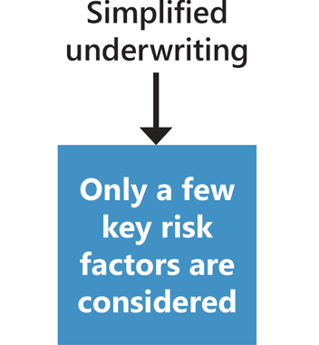
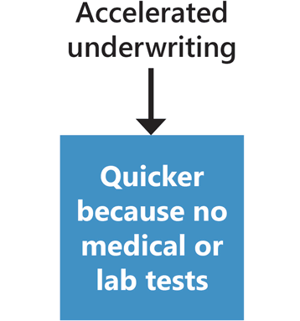
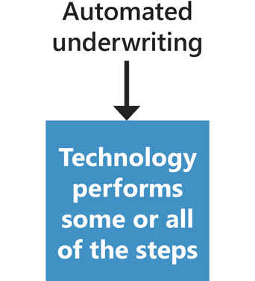
Automated underwriting relies on a business rules engine (BRE)—software that automates decision making. Insurers use BREs for exception-based underwriting, which automatically accepts some applications and refers the rest—that is, the exceptions—for further evaluation by a human underwriter.
Issuing Policies Faster
A life insurance policy is in force only after it has been delivered to and accepted by the policyowner. The new business unit compiles and, in many cases, prints out the policy and all the documents required by law in the governing jurisdiction. Often, the insurer mails the policy to the financial professional, who then delivers the policy to the policyowner. Sometimes the new business staff mails the policy directly to the policyowner.
Insurers can also deliver policies electronically. With e-delivery, the insurer either sends the policy as an email attachment or places it on a secure website for the policyowner to download.
Straight-Through Processing: One-Stop Shop
The shortest underwriting cycle pairs instant issue underwriting with straight-through processing. With instant issue underwriting, also known as real time underwriting, technology assesses an applicant's risk and instantly makes an underwriting decision. Straight-through processing is the electronic processing of all steps in the new business cycle without human intervention. When an insurer combines instant issue underwriting with straight-through processing, an applicant can submit an application, receive an underwriting decision, accept the decision, and receive the delivery of an in-force policy all in one brief internet session.
Instant Issue Underwriting +
Straight-Through Processing
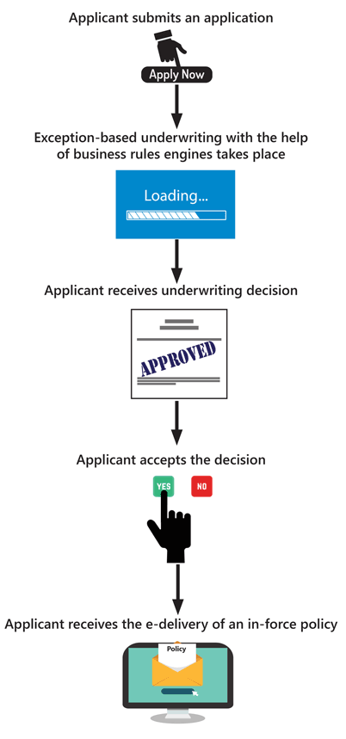
Insurers generally place an upper limit on the amount of insurance they will approve through instant issue, though such limits are climbing all the time.
Whether by a person, an automatic system, or a combination of the two, an insurance application needs to be evaluated for the risk it represents: the process of underwriting. This is what we will discuss in the remainder of this lesson.

Michelle Bloom submits an online application for $50,000 of life insurance on the insurer's website. The insurer's system automatically searches a variety of databases to obtain information such as a credit report, pharmacy report, and motor vehicle history, among others. The system applies a set of rules to this information and determines that the application meets the criteria for automatic acceptance and does not need to be referred to a human underwriter.

Ms. Bloom pays the initial premium with her credit card, and the system emails her a copy of her in-force policy.
Which of the following does this scenario illustrate? Choose all that apply.

- Straight-through processing
- Instant issue underwriting
- Exception-based underwriting

Underwriting Overview
Learning Objective
Describe the underwriting process and the importance of sound underwriting to a company's financial viability.
During underwriting, the insurer determines how much risk a proposed insured poses, classifies the risk, and decides whether to issue a policy or not.
The Underwriting Process
Once they receive the application, underwriters gather additional information as needed and proceed to make the underwriting decision. For a simplified overview of the underwriting process, see the following chart.
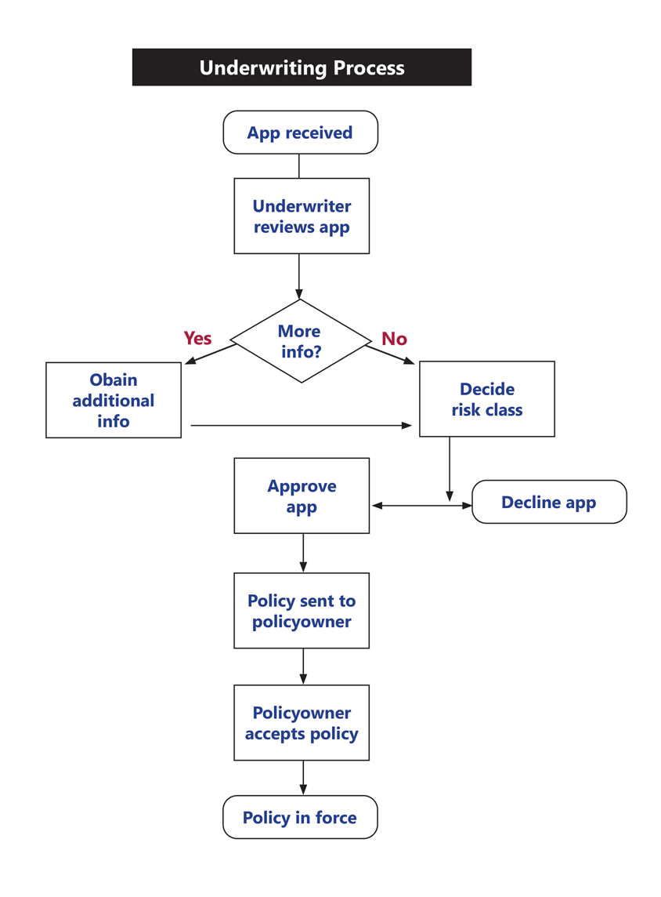
Importance of Sound Underwriting
The ultimate goal of underwriting is to accept the greatest number of qualified proposed insureds while keeping the insurer financially sound—a delicate balancing act.
It's up to every underwriter to engage in sound underwriting. Underwriting is considered to be sound if each risk is
- Assessed accurately
- Classified properly
- Approved for an appropriate premium rate or denied accurately
With sound underwriting, every insured pays his fair share for coverage. Riskier people pay more for coverage than less risky people.
How do underwriters evaluate risks and determine the premiums to charge for each proposed insured?
When a new insurance product is designed, actuaries make estimates about a product's inflows, such as premiums paid and investment income earned, and outflows, such as benefits paid and expenses incurred. For life insurance, an important element in determining these inflows and outflows is mortality risk—the likelihood that a person will die sooner than statistically expected.
If the mortality experience for a particular life insurance product is higher—that is, if more people die—than the insurer anticipated when the product was designed, then the inflows will be lower and the outflows will be higher than expected. In other words, the premium rate the actuaries established would not be sufficient to cover the benefits and expenses that must be paid and earn a profit for the insurer’s owners. For annuity products, mortality risk is the likelihood that a proposed insured will live longer than statistically expected.
Antiselection, Persistency, and Insurable Interest
Three concepts that are important to sound life insurance underwriting are antiselection, persistency, and insurable interest.
Antiselection is the tendency of people who are most likely to suffer a loss to seek insurance. The possibility of antiselection makes the underwriter's role particularly important in the risk assessment process.
Here, an expert discusses some red flags that underwriters look for to detect antiselection.
Persistency is the retention of business that occurs when a policy remains in force. For most life insurance policies, persistency depends upon the continued payment of a policy's renewal premiums. When assessing the risk posed by a proposed insured, underwriters must consider the likelihood that the policy will remain in force if issued. To offset costs related to underwriting and compensation of financial professionals, life insurance policies need to remain in force for several years before they are profitable to the insurer.
Insurable interest in life insurance is the requirement that a person seeking insurance should stand to suffer a genuine loss if the insured dies. Insurance is supposed to compensate for a financial loss if the insured dies—not provide a financial windfall.
A person is presumed to have an insurable interest in their own life. In addition, an insurable interest is presumed to exist between certain close family members. Consider the case of Juan, below. In the United States, which of Juan's relatives to you think would be presumed to have an insurable interest in Juan's life? Use the right arrow to see the answer.
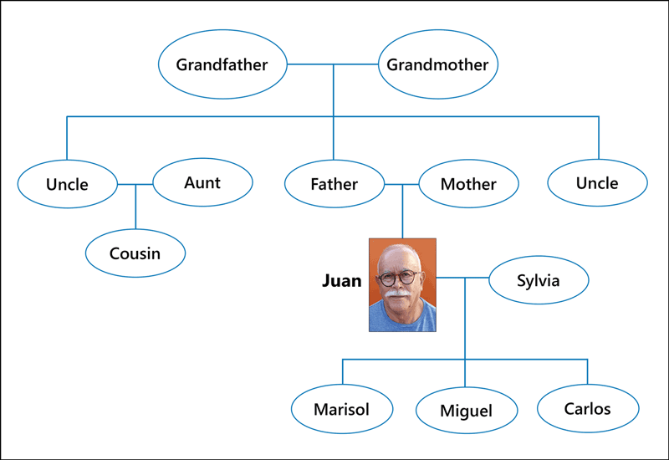
Who has an insurable interest in Juan's life?
In the United States, a proposed insured's spouse, children, grandchildren, siblings, parents, and grandparents typically have an insurable interest. Other relatives or loved ones can also meet the insurable interest requirement, but it is not presumed to exist.
If the applicant is someone other than the proposed insured, and not a relative with a presumed insurable interest, then the applicant must demonstrate an insurable interest. If the applicant cannot show an insurable interest in the proposed insured, the underwriter must deny the application.

True or False?
With sound underwriting, every insured pays his fair share for coverage. Riskier people pay more for coverage than less risky people.
- True
- False
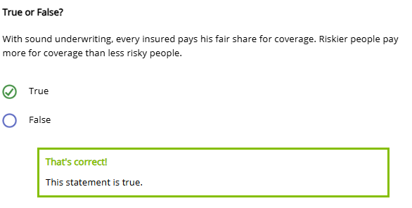
Trudy, a 43-year-old woman, received a life insurance application via direct mail and applied for a $500,000 policy. On her application, she said she'd never applied for or been denied coverage. However, she had applied for another policy with another insurer six months earlier. That insurer had denied coverage when it discovered that she'd been diagnosed with emphysema a year earlier.

- Persistency
- Antiselection
- Insurable interest
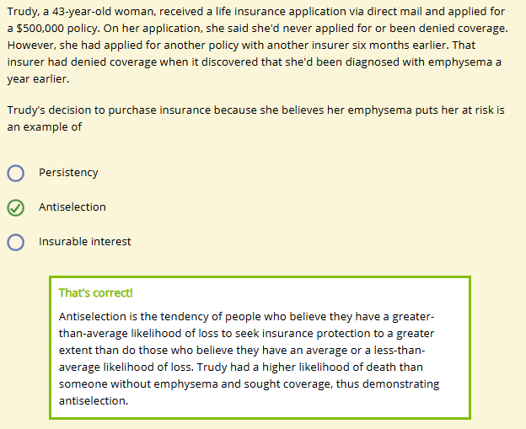
Trudy's decision to purchase insurance because she believes her emphysema puts her at risk is an example of

- Persistency
- Antiselection
- Insurable interest
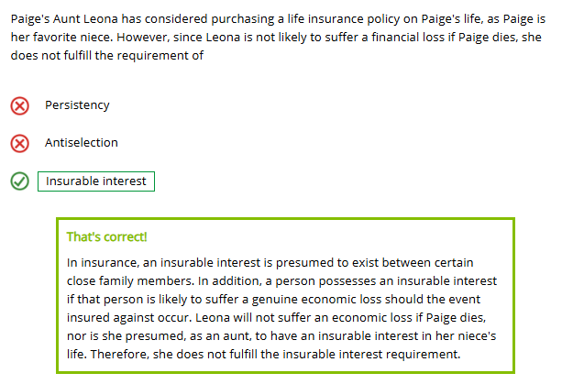

Field Underwriting and Teleunderwriting
Learning Objective
Describe the processes of field underwriting and teleunderwriting.
Field Underwriting
The underwriting process typically begins with field underwriting, in which a financial professional gathers basic information about the applicant and makes an initial assessment of the person's insurability.
Field underwriting saves home office underwriters from wasting time considering clearly uninsurable risks who may apply for insurance.

The home office gives financial professionals a field underwriting manual that assists their evaluation of the proposed insured. A field underwriting manual assists the financial professional in completing the application and gathering evidence of insurability.
Financial professionals report anything they discover during field underwriting that could influence an underwriter's decision. They make these reports in the agent's statement, a section included in most individual life insurance applications that enables the financial professional to comment on any factors relevant to the case.
Teleunderwriting
An alternative to the applicant and financial professional completing a lengthy insurance application is teleunderwriting, in which a home office employee or a vendor gathers underwriting information during a telephone or videochat interview. Often, the financial professional and the applicant complete an abbreviated application and the other required underwriting information is obtained during the teleunderwriting interview.
In teleunderwriting, the interviewer follows a prepared script of questions and enters the answers into a computerized system. A business rules engine may decide which questions need to be asked, based on the answers to the prior questions. For example, if a proposed insured tells the interviewer that she has a specific medical condition or takes certain prescription medications, the system guides the interviewer to ask relevant follow-up questions.
Insurers find that teleunderwriting often provides more complete and thorough information than does an application that the applicant completes with a financial professional because applicants feel more comfortable providing personal information to a stranger over the phone. Teleunderwriters are specially trained to ensure that all application questions are answered completely. In addition, phone conversations can be recorded and reviewed for quality assurance and to enhance an insurer's compliance activities.

Greg Bustos, a financial professional, works with a life insurance applicant to fill out an abbreviated application on his tablet. Mr. Bustos also submits an agent's statement, in which he notifies the insurer of some observations he has made about the applicant which might affect the underwriting decision. The next day, Robert Thompson, who works for a specialized vendor hired by the insurer, telephones the applicant and asks a series of scripted questions to obtain additional information necessary to process the application.
Which of the following does this scenario illustrate? Choose all that apply.
- Instant issue underwriting
- Teleunderwriting
- Straight-through processing
- Field underwriting
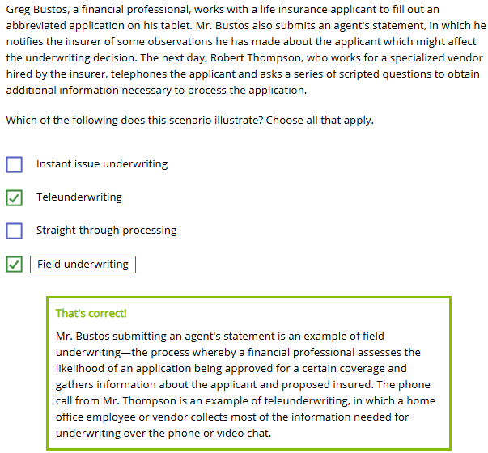
Select all the benefits of using teleunderwriting.
- No unanswered questions
- No incomplete answers
- No need to complete application


Categories of Risk Factors
Learning Objective
Identify and explain the three main categories of risk factors that underwriters consider.
Life insurance underwriters determine how much certain risk factors, also known as risk characteristics, affect a proposed insured's mortality risk.
The three main categories of risk factors are
- Medical
- Personal
- Financial
Medical Risk Factors
Medical risk factors are physical or psychological characteristics that may increase a person's mortality risk, including
- Build (body form or shape)
- Age
- Sex
- Personal medical history
- Family medical history
How do the following medical risk factors affect a person's mortality risk? Click or touch in the boxes below to find out.


Age
Older ages usually show higher mortality than do younger ages.


Sex
Males show higher mortality than do females of comparable age.


Health Characteristics
Health characteristics associated with higher mortality include being overweight, having high blood pressure, and having a poor individual and family health history.

Personal Risk Factors
Personal risk factors are lifestyle choices that can significantly affect a person's health or longevity.

What personal risk factors would affect a person's mortality risk? Choose all that apply.
- Occupation
- Tobacco use
- Alcohol and drug use
- Driving history
- Avocations
- Aviation activities
- Military status
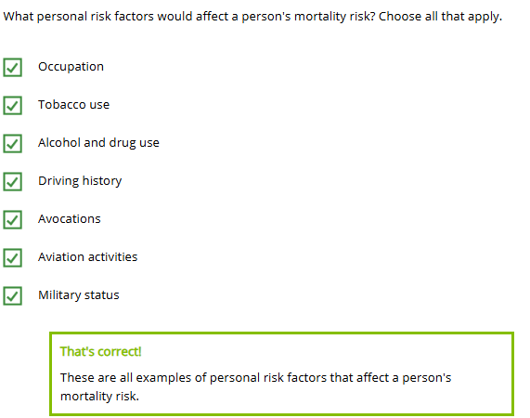

Click or touch in the boxes below to learn how different personal risk factors affect a person's mortality risk.


Smoker status/Tobacco use
At most ages, smokers and tobacco users have mortality rates more than double those of nonsmokers and non-users of tobacco.


Avocations
Participation in certain activities with a higher risk of accidental death—e.g., scuba diving and skydiving—can increase mortality risk.


Occupation
Individuals with certain dangerous occupations have a higher mortality rate than individuals who do not have such occupations.

Financial Risk Factors
Financial risk factors are the financial information that an underwriter considers to determine whether a person is applying for more insurance than he reasonably needs or can afford.
Examples of financial risk factors include
- Current income
- Potential income
- Net worth
Underwriters evaluate financial risk factors to ensure that the proposed insured needs the coverage applied for, and that a reasonable relationship exists between the need for the coverage and the amount of coverage applied for. The type of policy and amount of coverage should be appropriate and reasonable for the person's specific needs and financial situation.
If the applicant and beneficiary seek an excessive amount of insurance on the proposed insured, they may be wagering on whether the insured will live. Such a wager is against public policy.

Financial risk factors also help underwriters consider if the premium is affordable for the applicant. If the proposed insured can't afford the premiums, the policy may lapse, or terminate. Unexpected lapses are bad for the persistency rate and can lead to poor financial results.

True or False?
An underwriter does not usually consider an individual's family health history as a medical risk factor for life insurance.
- True
- False
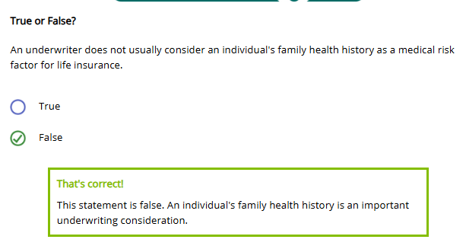
Underwriters evaluate financial risk factors to ensure (choose all that apply):
- The amount of coverage is appropriate and reasonable for the person's specific needs
- The premium is affordable for the applicant
- The applicant's occupation is safe and appropriate
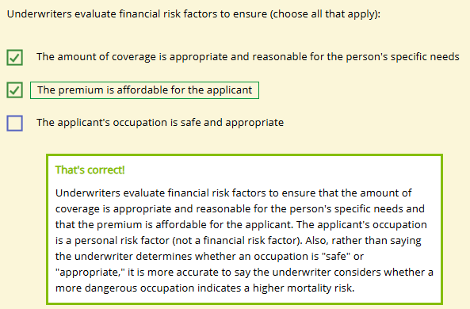

Sources of Information and Underwriting Tools
Learning Objective
Identify and describe the various sources of information and underwriting tools that underwriters use to assess risk.
Insurance Application
The insurance application is an underwriter's best overall source of information for assessing the risk of a proposed insured.
Traditionally, insurers have divided their life insurance applications into two parts—Part I and Part II—but it's becoming more and more common for these parts to be referred to as nonmedical and medical. Both parts give underwriters valuable information needed to assess the risk of a proposed insured. Click or touch each heading below to learn more.
Nonmedical
The nonmedical part of the application gives some of the information needed to evaluate whether the amount and type of insurance are appropriate for the proposed insured:
- Annual income
- Purpose of insurance
- Beneficiary and his relationship to the proposed insured
- Type of plan applied for
- Face amount applied for
- Quoted premium
The nonmedical information becomes part of the insurance contract when signed by the applicant, proposed insured, and the financial professional.

Medical
The medical section of a life insurance application provides detailed medical information about the proposed insured.
The proposed insured answers questions about her medical history and signs this portion of the application, which becomes part of the contract.
This section takes one of three forms:
- Nonmedical supplement—the medical history provided by the applicant, with or without the participation of a financial professional or teleunderwriter
- Paramedical report—the medical history recorded by a paramedic plus the findings of a paramedical exam
- Medical report—the medical history recorded by a doctor plus a doctor's medical exam findings
Characteristics of the proposed insured, such as his current health and health history, family health history, and the amount of insurance applied for, determine whether a nonmedical supplement is sufficient or whether the proposed insured will be asked to undergo a paramedical or medical exam.
The choice of medical form is important because of cost. A medical report is expensive, a paramedical report less expensive, and the nonmedical supplement is the cheapest of all. The form used is also important because of the amount of time it takes and the level of inconvenience it represents for the proposed insured. The lengthier and more onerous the underwriting process, the more likely that the applicant will not complete the process.

Other Sources of Information
To gauge a person's medical risk factors, underwriters may use other sources of information besides the application.
More Sources of Medical Risk Information
Medical Risk Factor | Source of Information
Build, age, sex | Attending physician's statement (APS)
Health history | APS, medical questionnaire, blood profile, ECG, MIB reports, pharmaceutical databases
Family history | APS
More Sources of Personal Risk Information
Personal Risk Factor | Source of Information
Tobacco use | Inspection report
Alcohol and drug use | Inspection report
Driving history | Motor vehicle record
Avocations | Personal questionnaire
Aviation activities | Personal questionnaire
Military status | Military questionnaire
But remember: gathering information costs money. The greater the risk, the more information the underwriter will want.
So, if the proposed insured is 63 and the policy is for $1 million, the underwriter will want to gather more information than if the proposed insured is 38 and the policy is for $250,000.
More Sources of Financial Risk Information
When evaluating risk, an underwriter engages in financial underwriting, assessing a proposed insured's financial condition to determine whether (1) the proposed insured needs the coverage applied for, (2) a reasonable relationship exists between the need for the coverage and the amount of coverage applied for, and (3) the applicant can afford the coverage.
Underwriters rely on the application to aid in financial underwriting, as the application usually provides the necessary information. Sometimes, an underwriter also may need
- An inspection report
- Tax documents
- A financial questionnaire
- Financial statements
Underwriting Tools
Underwriters use a tool called an age and amount requirements chart, also known as a table of underwriting requirements, to assess the insurability of a proposed insured for coverage for a specific product. Generally, the riskier the proposed insured appears to be from his age and the amount of insurance applied for, the more information the underwriter will need and the more information-intensive form the financial professional should use.
Face Amount | Ages
 | 16-40 | 41-50 | 51-60 | 61-70 | 71+
$0 to $99,000 | Nonmedical | Nonmedical | Paramedical  Urine specimen | Paramedical  Urine specimen | Paramedical  Blood profile  Urine specimen  Cognitive function test
$100,000 to $250,000 | Nonmedical | Paramedical  Blood profile  Urine specimen | Paramedical  Blood profile  Urine specimen | Paramedical  Blood profile  Urine specimen | Paramedical + ECG  Blood profile  Urine specimen  Cognitive function test
$250,001 to $1,000,000 | Paramedical  Blood profile  Urine specimen | Paramedical  Blood profile  Urine specimen | Paramedical  Blood profile  Urine specimen | Paramedical + ECG  Blood profile  Urine specimen | Paramedical + ECG  Blood profile  Urine specimen  Cognitive function test
$1,000,001 to $2,500,000 | Paramedical  Blood profile  Urine specimen | Paramedical  Blood profile  Urine specimen | Paramedical + ECG  Blood profile  Urine specimen | Paramedical + ECG  Blood profile  Urine specimen | Paramedical + ECG  Blood profile  Urine specimen  Cognitive function test
$2,500,001 to $5,000,000 | Paramedical  Blood profile  Urine specimen | Paramedical + ECG  Blood profile  Urine specimen | Paramedical + ECG  Blood profile  Urine specimen | Paramedical + ECG  Blood profile  Urine specimen | Paramedical + ECG  Blood profile  Urine specimen  Cognitive function test
$5,000,001 to $10,000,000 | Paramedical  Blood profile  Urine specimen | Paramedical + ECG  Blood profile  Urine specimen | Paramedical + ECG  Blood profile  Urine specimen | Paramedical + ECG  Blood profile  Urine specimen | Paramedical + ECG  Blood profile  Urine specimen  Cognitive function test
$10,000,001 and over | Paramedical + ECG  Blood profile  Urine specimen | Paramedical + ECG  Blood profile  Urine specimen | Paramedical + ECG  Blood profile  Urine specimen | Paramedical + ECG  Blood profile  Urine specimen | Paramedical + ECG  Blood profile  Urine specimen  Cognitive function test
Example
Forthright Financial underwriter Claire MacKenzie is evaluating a proposed insured's application and trying to determine which medical information will be required to assess the applicant's insurability. The proposed insured is 62 years old and applying for $250,000 in coverage. According to the age and requirements chart, this applicant will need to supply a paramedical report, blood profile, and urine specimen for evaluation.
An underwriter also uses a factor table, a chart that shows the maximum amount of insurance—expressed in multiples of a person's salary or current gross earned income—that an insurer typically approves in each of several age ranges, to determine the maximum amount of life insurance the insurer will approve on a proposed insured.
Look at the factor table below and consider the following example:
Insured's Age | Multiple of Insured's Gross Income
20-40 | 20
41-50 | 15
51-60 | 10
61-64 | 5
65 & over | 4
Example
Daniel Rose is an underwriter at Forthright Financial. He is evaluating a proposed insured's application and trying to determine the maximum amount of insurance the applicant can be approved for. The proposed insured is 47 and earns an income of $85,000 per year. According to the factor table, the highest amount of insurance coverage Daniel can approve for the applicant is $1,275,000.
85,000 (insured's gross income) X 15 (multiple for age range 41-50) = 1,275,000

In order to assess a proposed insured's personal risk factors, an underwriter may review the following documents (choose all that apply):
- Inspection report
- Military questionnaire
- High school transcript
- Motor vehicle record
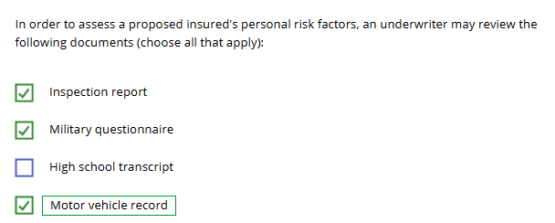
Refer back to the age and amount requirement chart and determine the most appropriate medical form for each situation.
A 38 year old applying for $200,000 of life insurance.
- Medical
- Nonmedical
- Paramedical + Urine specimen
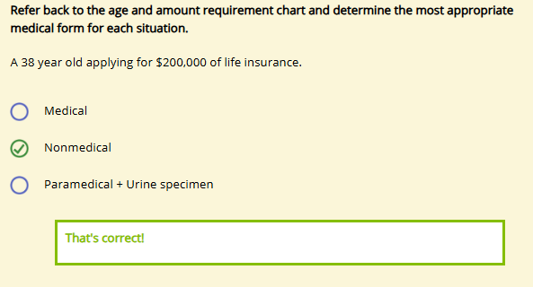
A 44 year old applying for $1,000,000 of life insurance.
- Paramedical + Blood profile + Urine specimen + ECG
- Nonmedical
- Paramedical + Blood profile + Urine specimen
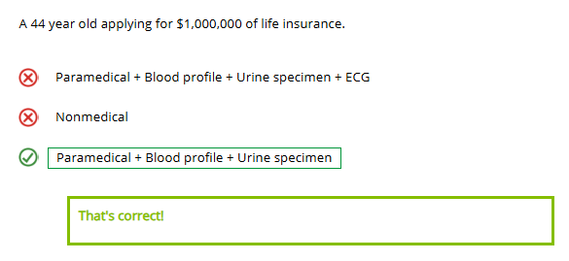
A 62 year old applying for $500,000 of insurance.
- Paramedical + Blood profile + Urine specimen + ECG
- Nonmedical
- Paramedical + Blood profile + Urine specimen + ECG + Cognitive function test
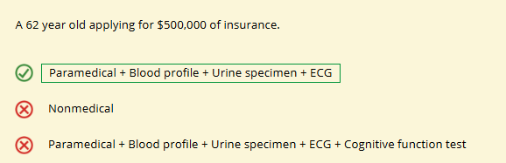
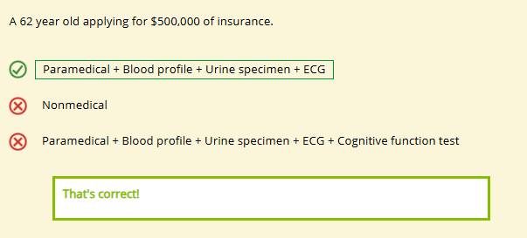
Insured's Age | Multiple of Insured's Gross Income
20-40 | 20
41-50 | 15
51-60 | 10
61-64 | 5
65 & over | 4
Susanna Bling is 53 years old and her annual gross income is $100,000. According to the factor table above, what is the maximum amount of insurance coverage she could purchase, assuming she is an insurable risk?
- $400,000
- $500,000
- $1 million
- $1.5 million
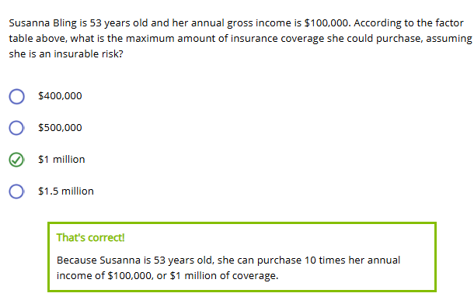

Classifying Risk
Learning Objective
Explain how insurers classify risks and make an underwriting decision.
As we've discussed, deciding the risk a person represents to an insurance company is a combined effort of actuaries and underwriters.
- Actuaries determine the premium rate per risk group
- Underwriters place individual insureds into the appropriate risk group
Premium Rates
To set the premium rate for a life insurance product, actuaries have to make predictions about, among other factors,
- How many insured people will die each year
- How many policyowners will lapse or surrender their policies
Actuaries set premium rates based on their predictions for a large group of insureds. But underwriters must accurately assess and classify each risk.

Why?
To charge each policyowner an appropriate premium for the degree of risk in each policy in order to meet actuarial predictions.
What happens if risks are accepted at premium rates that are not adequate for their true risk?
The insurer will pay more in claims than it can afford. Plus, the insurer could face consequences, such as
- Disciplinary action from insurance regulators
- Loss of reputation
- Poor financial results
- Insolvency
Classifying Risks
Once the underwriter has all the information she needs, she can accurately assess the proposed insured.
Forthright uses a numerical rating system to calculate a proposed insured's total mortality risk. A numerical rating system is a method of assigning a numerical value to a proposed insured corresponding to the person's mortality risk.
The system has three basic steps:
- Start with a base of 100 (standard mortality)
- Assign a positive number (a debit) for each risk factor that has been determined statistically to increase a person's mortality risk
- Assign a negative number (a credit) for each risk factor that has been determined statistically to have a favorable effect on mortality
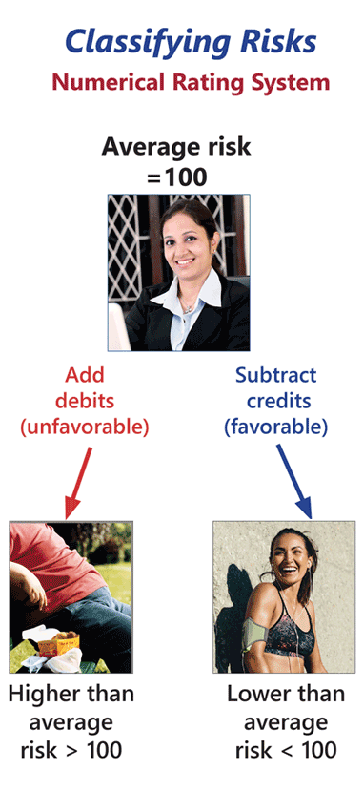
Example
Yogi Grizzoli is a 47-year-old male non-smoker who weighs 255 pounds and whose parents are still alive. His medical records indicate that he is a diabetic with onset at age 40. He controls his diabetes with diet. His blood work, attending physician statement, and ECG results are all favorable. The underwriter assigned the following debits and credits:
Standard Mortality Rating | 100
Build | +75
Both parents alive | -10
Diabetes onset at age 40 controlled by diet | +50
Favorable blood work, APS, ECG | -25
 | 190
Yogi has 125 debits and 35 credits. The underwriter adds these debits to the standard mortality rating of 100, and subtracts the credits, for a total mortality rating of 190 for Yogi.
Risk Classes
Underwriters use a risk classification system to assign new business cases to a risk class and to an associated rate table.
Each insurer sets its own risk classes, but some risk classes are typical. Click or touch the right arrows below to learn more.

Standard risk class
Average risk.
Average premiums.
A proposed insured's risk class determines in part the premium Forthright will charge.
Table Rating
How does Forthright's underwriter assign Yogi to the proper risk class? The underwriter consults Forthright's extra-percentage table, a document that presents the total mortality for each substandard group and that lists all the tables used in the table rating method. She uses this document to determine which broad group—or table—Yogi's score lands him in. Each table corresponds to a risk class.
An Extra-Percentage Table*
Risk Class | Debits/Credits | Table | Typical Risk Factors
Preferred | <100 |  | Excellent health
Standard | 101-149 | A | Good health
Low-Substandard | 150-210 | B-D | Moderately controlled diabetes, heart disease, cancer
High-Substandard | 211-325 | E-I | Fairly controlled diabetes, recent heart surgery or event, recent cancer treatment
Decline | >325 | J or greater | Chronic disease not well controlled, terminal illness, newly diagnosed condition, multiple impairments
*Varies depending on company pricing and underwriting philosophy

Select the risk class in which Yogi would fall on Forthright's extra-percentage table.
An Ethical Dilemma
let examine a situation similar to ones that underwriters sometimes face.

"Hi, Tanya. This is Erick calling about the $1.5 million app on Yogi Grizzoli. You people have delayed this process every step of the way, and my guy is getting a little impatient. I'm tempted to place him with Best Value, but I'd hate to start the process over again."

"Well, Erick, it appears your guy isn't as healthy as your agent's statement would have us believe. According to our underwriting guidelines, our best offer is Table C."

"No way! Work with me here, and we may also get the major annuity with this one. I know company guidelines say you have to offer C, but Best Value's underwriters always meet me half way. If you'd make it an A, that would really help me. Come on Tanya. You know you can bend the rules here."

"Go ahead. Forthright might tell you to rate proposed insureds according to guidelines, but at the same time it's pushing you to get business. Erick is one of Forthright's best agents, and you know he'll just go to your boss if he doesn't get his way. That could mean trouble—and cost you your next raise."

"You can't be serious! Forthright counts on you to protect the bottom line by charging a customer a fair premium for the risk we're taking. Not to mention, if you give in this time, Erick will try to bully you every time he wants a rate reduction. Hold firm!"

As you can see, financial professionals sometimes pressure underwriters to accept less-than-ideal business. Would it be so bad if Tanya gave in to Erick and accepted business that might have gone to the competition?
The answer is YES! Accepting that application would have violated Forthright's underwriting guidelines, and no application is worth that. Every employee can make a difference for their company by acting ethically.

"I just can't do it, Erick. If I did, I'd be fighting the antiselection battle, with other agents bringing me all kinds of lousy cases that other companies won't accept. Plus, if I made a practice of this and the reinsurers found out we weren't following our guidelines, they might start denying claims."
Making the Underwriting Decision
If the application is approved as a preferred or standard risk, then new business processing creates a policy record and arranges for any special services requested by the applicant—such as an automatic premium payment plan. The policy is then issued and either mailed directly to the policyowner or sent to the financial professional to deliver to the policyowner. The policy is in force when it is accepted by the policyowner.
If the proposed insured has certain medical, personal, or financial risk factors but is still considered insurable, the application is rated: that is, approved, but at a higher than average premium rate, or with a modified type or amount of coverage. For example, a proposed insured with a history of diabetes could be approved for the requested coverage as a substandard risk. The substandard-rated policy would require a higher-than-standard premium rate. The term rated policy is generally used for a policy approved at a substandard rate. (Some companies use the term "rated policy" for any policy accepted at other than the standard rate—be it substandard or preferred.)
When a policy is rated as a substandard risk, new business processing contacts the financial professional who submitted the application and explains why the policy was rated. If the applicant accepts the rated policy, then the policy is in force; if not, then no policy is in force.
To modify coverage, the underwriter may approve the policy at the requested premium rate but offer a lower amount of coverage than requested, or she may limit the coverage by modifying the terms of the contract.
The underwriter can choose to decline the risk and not issue the policy.
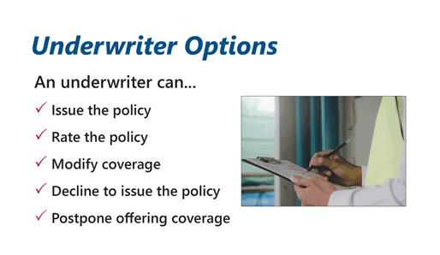
In some situations, an underwriter can postpone making an underwriting decision, usually for a specified period of time such as 6, 12, or 24 months. For example, if a proposed insured is going to be deployed into a war zone or undergo a risky medical surgery, the underwriter can postpone the decision until after that level of risk has been reduced.

Risk Class | Debits/Credits | Table | Typical Risk Factors
Preferred | <100 |  | Excellent health
Standard | 101-149 | A | Good health
Low-Substandard | 150-210 | B-D | Moderately controlled diabetes, heart disease, cancer
High-Substandard | 211-325 | E-I | Fairly controlled diabetes, recent heart surgery or event, recent cancer treatment
Decline | >325 | J or greater | Chronic disease not well controlled, terminal illness, newly diagnosed condition, multiple impairments
Carmen Hernandez is a 67-year old female non-smoker of average weight and whose parents are deceased. Her medical records indicate that she suffers from hypertension and mild depression. She treats both of these conditions with medication. Her blood work, attending physician statement, and ECG results are all favorable. The underwriter assigned the following debits and credits:
Build | -10
Both parents deceased | +30
Hypertension, onset 2 years ago (treated with medication) | +30
Mild depression, onset 3 years ago (treated with medication) | +20
Favorable blood work, APS, ECG | -30
When the underwriter adds these debits to the standard mortality rating of 100, and subtracts the credits, he finds a total mortality rating of ______ for Carmen.
Based on this total mortality rating, Carmen's risk class will be ______.
- 160, Low-Substandard
- 140, Standard
- 140, Preferred
- 120, Standard
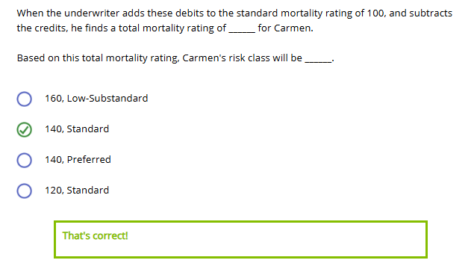
Forthright received applications for individual life insurance from the following two people:

- Cho Lin's mortality risk is significantly lower than average.
- Estelle Galloway's mortality risk is higher than average, but Forthright's underwriters consider her to be insurable.

Choose the response below that correctly identifies how Forthright's underwriters would classify Mr. Lin and Ms. Galloway.
- Mr. Lin as standard and Ms. Galloway as substandard
- Mr. Lin as standard and Ms. Galloway as declined
- Mr. Lin as preferred and Ms. Galloway as substandard
- Mr. Lin as preferred and Ms. Galloway as declined
